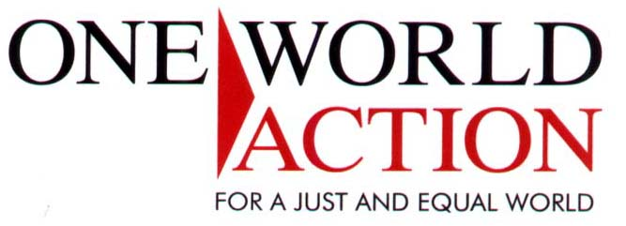

Using Gift Aid means that for every pound you give, we get an extra 28p from the Inland Revenue (25p comes from tax relief, 3p comes from additional Government expenditure) helping your donation go further.

This means for example that for a donation of £10 we will actually get £12.80 so long as you complete this form and send it back to us. Just imagine what a difference that could make - and it doesn’t cost you a thing!

To qualify for Gift Aid, what you pay in income tax or capital gains tax must at least equal the amount we will claim in the tax year.

Higher rate taxpayers who pay tax at 40% can claim tax relief for themselves at 20% (40% less 20%) of the gross donation by including the donation in their annual tax return. They may also donate this additional 20% to One World Action if they so wish.

If you have any queries please call the fundraising team on 020 7833 4075.

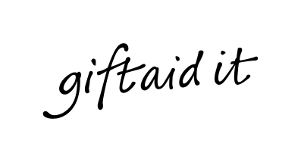
I am a UK taxpayer and would like One World Action to reclaim the tax I have paid on all donations since 6 April 2000 and any future donations I may make. I will contact One World Action if this situation changes.

Full Name:…………………………………………………………………………..
Address:…………………………………………………………………………….
…………………………………………… Post code:…………………………….
Signed:………………………………………………… Date:………………………………….

 If you are not a UK taxpayer, you may wish to advise us by ticking this box and we will mark our records accordingly

Thank you for taking the time to make your donation go further.

Please return this form to: Fundraising Department, One World Action, Bradley’s Close, White Lion Street, London N1 9PF
Charity Registration Number: 1022298

