Fundraising Pack

One World Action Fundraising Pack

Contents Page No

About One World Action 3
How Your Money Helps 4
Fundraising for One World Action 5
Setting Up Your Own Sponsorship Webpage 6 - 7
Legalities 8
Sending Money to One World Action 9
Gift Aid Form 10
Sponsorship Forms 11 - 12

About One World Action

One World Action works with communities in Africa, Asia and Central America to create the power and opportunity for the poorest people to transform their own lives. We campaign to challenge international policies that make and keep people poor by building bridges between key policy makers over ‘here’ in Europe, and over ‘there’ in the developing world.. We work on basic services in a range of sectors – education, healthcare, water supply, access to justice –but above all emphasise the need for people to have a real voice in decisions that affect their lives.

We work directly with partner organisations and communities. We do not have expatriate field staff or fleets of vehicles. Instead 93p from every £1 we raise goes directly to the people who need it most. This means that OWA partners like Development Workshop in Angola have more funds to tackle the problem of vastly expensive, dirty and unsanitary drinking water. With the support of Development Workshop, local people now sit on a water committee and negotiate with the government, ensuring that these Angolan children have a supply of clean affordable drinking water.
© Nick Danziger/NB Pictures/OWA

One World Action began as a small trust in 1989. Joined by the Nicaragua Health Fund in 1993, OWA now has an annual turnover of more than £4 million. We have a track record that shows we punch above our weight and last year our work directly reached one million of the world’s poorest people.

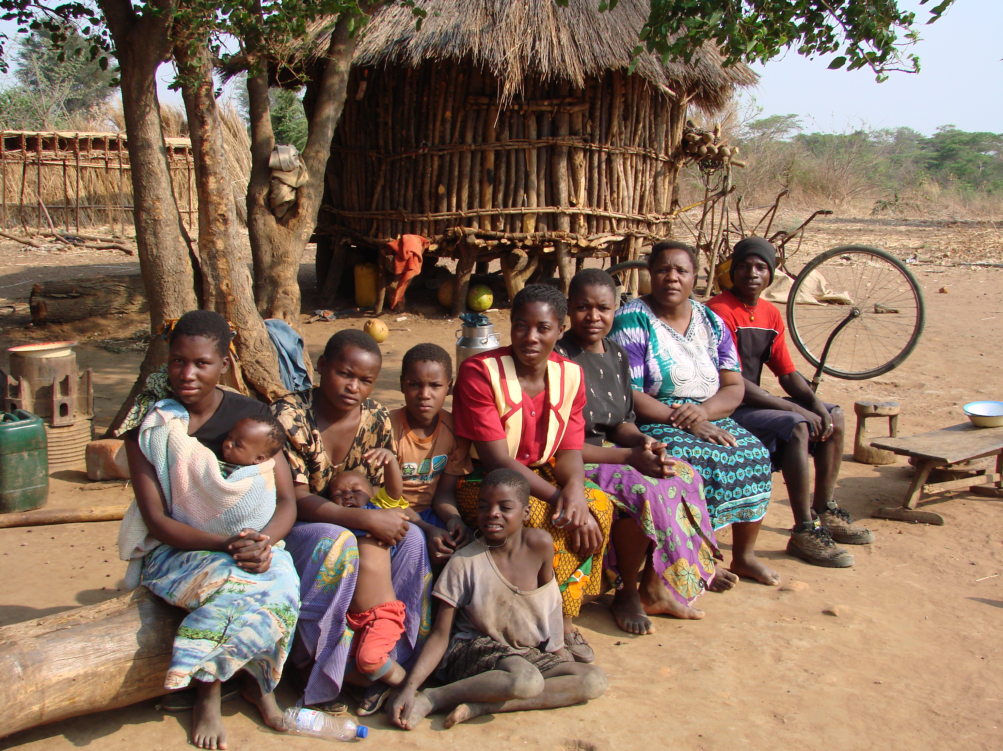

How Your Money Helps

One World Action relies upon donations from supporters to fund its vital work. Last year, with your help, we directly helped over 1 million people in developing countries around the world.
By raising funds for One World Action you are helping us to continue our work to transform sustained poverty into sustainable development. Here’s some of the ways in which your money could help.
£15 will give a family in Angola access to clean water through a communal standpipe

£60 provides physiotherapy for 12 disabled children in El Salvador

£150 will supply a bicycle ambulance for a community in Malawi

£500 trains a female paramedic in the slums of Dhaka, Bangladesh

What our partners say

“The partnership with One World Action is based on respect, solidarity and the wish to transform local development and make it globally applicable in a just and harmonious way. It is a partnership that looks for solutions for the most disadvantaged and excluded, through active participation and a real exercise of citizenship by those who, due to their poor conditions have less ‘Voice’.” Elisio Rodrigues, Citi-Habitat President, OWA partner, Cape Verde

“The relationship with One World Action is excellent.” (from DfID evaluation report of work of Maria Elena Cuadra (MEC), Nicaragua

Fundraising for One World Action

Raising funds is both fun and challenging. Here are some top tips to help you get started. If you have any questions or comments call Verity on 020 7833 4075.

Fundraising tips & hints

- Web-wise: Create your own sponsorship webpage on www.justgiving.com and e-mail it to your friends. They can donate quickly and easily online with a credit or debit card. Simply follow the instructions on pages 5 -6.

Leaping for Democracy

Fantastic Fundraisers
- Double your money: Ask your company to open the corporate wallet and match what you raise.
- Dancing on the ceiling: Hire a function room over a pub (often free on a weeknight) and invite your friends to get down for a good cause.
- Food for thought: Invite your friends over for a fundraising dinner at £10 a head. Or organise a pancake party for a larger group.
- eBay Sell your unwanted items on eBay for OWA and add the proceeds to your sponsorship total (Ask the fundraising team for more information)
- Everyone’s a winner: Host a Vegas style poker night: £10 to play, gamble with chips, winners get prizes.
- One lump or two?: If you work at a large organisation, e-mail the database asking your colleagues to sponsor you the price of their morning coffee. It adds up fast!
- Cash for questions: Pick the brains and pockets of local punters by hosting a Quiz Night at your favourite pub.
- And the winner is…: Raffles. It’s an old favourite, and a nice little earner.
- Spring clean: Empty that cupboard under the stairs and flog your old junk on e-bay or at a car-boot sale.
- Nobody says no to cake: Bake some cakes and cookies and take them down to your sports club on a Saturday. Make sure you’re there for the half-time munchies.
- GOOOAAAAL! Organise a sweepstake. Your friends pay £3 and pick a country out of a hat. The winner gets half the total cash and the rest is donated.
- Prizes, prizes, prizes: Ask companies to donate bottles of wine, chocolates, vouchers, that you can use as prizes for quizzes and raffles.

SETTING UP YOUR OWN SPONSORSHIP WEBPAGE

The easy way to raise sponsorship!

You can now raise your sponsorship money without even leaving your chair…No more dealing with cash or cheques, no more hassling friends and family.

All you do is create your own Internet sponsor page, email it to all your friends and get them to donate quickly and easily online with a credit or debit card. Plus, online donations from UK taxpayers collect a 28% tax bonus!

Just go to charity website www.justgiving.com/charity/oneworldaction click on ‘Create your page’ then follow the simple instructions. By creating your own online sponsor page you can:

- Email the page to all your friends
- Watch your total grow on screen
- Include a photo and personal message
- Update your target amount as often as you like
- Get a 28% tax bonus added to your donations

Justgiving automatically reclaims 28% tax on every donation from a UK taxpayer – making it quicker for you to reach your target amount and ensuring more money goes to help our cause. Its secure servers mean all card information is totally safe.

So create your page for
One World Action today at
www.justgiving.com/charity/oneworldaction

Step-by-Step Guide to Setting Up Your Own Sponsorship Webpage

You can simply follow the instructions on the website, but for extra assistance, here are all the steps from the beginning. If you get stuck, please contact Justgiving’s helpdesk – details below.

Go to www.justgiving.com/Charity/oneworldaction

Click on ‘Create your page’

Select your event

Fill in your details. Click ‘Continue’

Personalise your sponsorship page. You may add a special greeting and thank you message and will also have the opportunity to submit a photo. But don’t worry, this can be done at any time.

Click to ‘preview your page’.

Justgiving will send you a confirmation e-mail that will include your web address which you can then send to potential sponsors.

Justgiving Help Desk
Phone 08000 286183 (9am-6pm – Mon-Fri)
Email helpdesk@justgiving.com

Or contact Verity at One World Action on 020 7833 4075

Fundraising Legalities

Collecting money and fundraising for charities is governed by a number of regulations to ensure that people do not secure funds fraudulently. Here are a few things to keep in mind when you are fundraising on behalf of One World Action.

- On any printed materials you produce (including letters, tickets, posters etc.) you must state ‘One World Action is a registered charity number 1022298’.
- Anyone collecting for charity in a public place needs a Street Collection Licence from the local authority (the council or metropolitan borough).
- To collect sponsorship or donations on private property, such as in a supermarket, a single pub or a train station, you only need the permission of the owner or store/station manager.
- Collecting from one place to the next (this includes business premises like pubs as well as houses) needs a House to House Collection Licence. Again, these can be obtained from your local authority.
- To hold a lottery or raffle you will need a Lotteries Licence from your local authority. The exception to this rule is for raffles held at a one-off event like a dinner or dance. Tickets can only be sold during the event and the result must be drawn at the event.

If you would like any help or advice please call Verity on 020 7833 4075

£ Sending Money to One World Action

Paying money in by post

All cheques should be made payable to One World Action and forwarded to us as and when you receive them. Please include a copy of the donation form when you send us cheques so that we are able to credit the money that comes in to your fundraising activities.

If you are collecting money from lots of sponsors then the easiest way of sending us the funds is to send us one cheque at the end of your fundraising with your donation form. In this instance, please remember that cheques from your sponsors will need to be made payable to you.

If you send us a large number of cheques, you may want to send them by registered post.

It is not safe to send cash in the post.

Paying money in by credit or debit card

If you have paid money from your sponsors into your own account and would like to pay be credit or debit card then please call Krista on 020 7833 4075 and you can pay over the phone.

Paying in money via www.justgiving.com

If you set up a sponsorship website page at www.justgiving.com (see pages 5-6) then the sponsorship money that you have raised including Gift Aid is paid directly to One World Action.

** N.B. If you are a UK Taxpayer and are sending us a cheque, please remember to send us a Gift Aid Declaration (p.10) so that we can claim back the tax and increase your donation by 28% at no extra cost to you.**

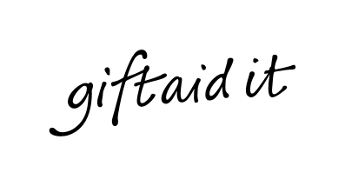
Using Gift Aid means that for every pound you give, we get an extra 28 pence from the Inland Revenue, helping your donation go further.

This means for example that for a donation of £10 we will actually get £12.80 so long as you complete this form and send it back to us. Just imagine what a difference that could make, and it doesn’t cost you a thing!

To qualify for Gift Aid, what you pay in income tax or capital gains tax must at least equal the amount we will claim in the tax year.

Higher rate taxpayers who pay tax at 40% can claim tax relief for themselves at 18% (40% less 22%) of the gross donation by including the donation in their annual tax return. They may also donate this additional 18% to One World Action if they so wish.

If you have any queries please call Verity on 020 7833 4075.

I am a UK taxpayer and would like One World Action to reclaim the tax I have paid on all donations since 6 April 2000 and any future donations I may make.
I will contact One World Action if this situation changes..

Full Name:…………………………………………………………………………..……………..

Address:………………………………………………………………………………………….

………………………………………………………… Post code:…………………………….

Signed:………………………………………………… Date:………………………………….

 If you are not a UK taxpayer, you may wish to advise us by ticking this box and we will mark our records accordingly

Thank you

Please return this form to:
Verity Owers, One World Action, Bradley’s Close, White Lion Street, London N1 9PF
Charity Registration Number: 1022298

SPONSORSHIP FORM

Name___________________________________________________________________________

Address_________________________________________________________________________________________________________________________________________________________________________________________________________________________________________

The person named above has agreed to fundraise on behalf of One World Action (Registered Charity No. 1022298).
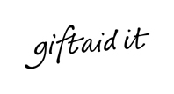
Use gift aid and you can make your donation worth more. For every pound you give to us we get an extra 28 pence from the Inland Revenue. So just tick below. It’s that simple.

To qualify for Gift Aid what you pay in income tax or capital gains tax must at least equal the amount we will claim in the tax year.

PLEASE BE AS GENEROUS AS YOU CAN – THANK YOU FOR YOUR SUPPORT

Name | Home Address & Postcode (Required for gift aid) | Amount | Gift Aid | Date Given

Name | Address & Postcode (Required for gift aid) | Amount | Gift Aid | Date Given

