
A meeting room at our premises is available for hire.
Based in Islington London N1 we are a 2 minute walk from Angel Tube (on the Northern Line) and easily accessible on bus routes 30, 73 and 476.

Seating:
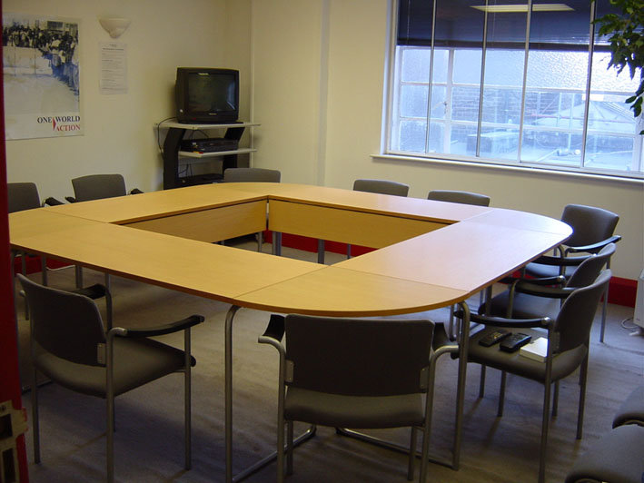
Formal setting boardroom style for up to 12 people.
Informal set-up for a maximum of 20 people seated.

Equipment & Facilities available:
- Overhead Projector with facility to project PowerPoint and other PC-based presentations.
- Internet access, flip charts.
- Induction loop for hearing aid users.
- Access to kitchen and tea and coffee will be available but catering not provided.

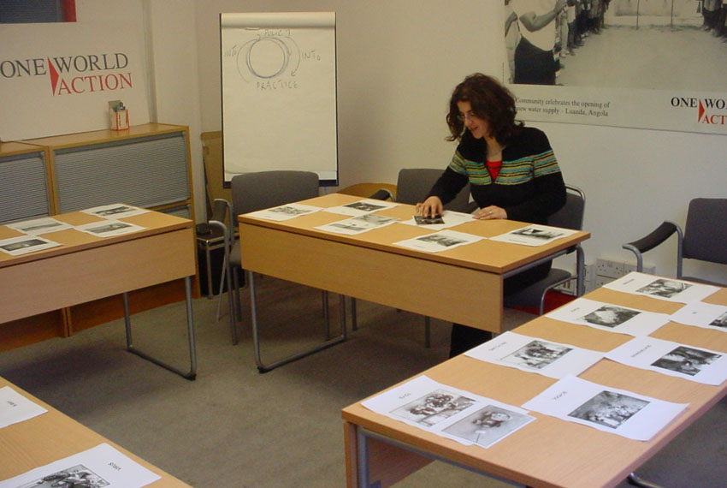
Rates: Hourly charge is £17.00 per hour or part hour.
All day cost is £100.00

Contact: Owen Evans – oevans@oneworldaction.org

Please note One World Action office is a non-smoking environment.

One World Action
Bradley’s Close
74-77 White Lion Street
London N1 9PF
Tel: 020 7833 4075 Fax: 020 7833 4102
Web: www.oneworldaction.org

